In-Depth Research Report on: Buffer Overflow and Long Password DoS Attacks



1. Introduction
Buffer overflow vulnerabilities and Denial of Service (DoS) attacks, particularly those using long passwords, are significant security threats in modern computing. This report explores buffer overflow attacks, their types, impacts, mitigation strategies, and discusses long password DoS attacks.

2. Buffer Overflow Attacks

2.1 Definition
A buffer overflow occurs when data written to a buffer exceeds its allocated size, causing the overflow to overwrite adjacent memory. This can lead to erratic program behavior, crashes, or exploitation by attackers to execute arbitrary code.

2.2 Types of Buffer Overflow Attacks
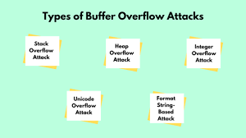
Stack-based Buffer Overflow: This occurs when the overflow affects the stack memory, often overwriting the return address of a function, allowing the attacker to redirect execution flow.
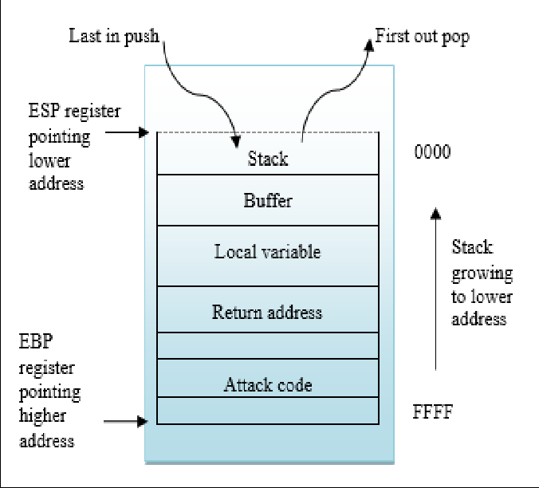
Heap-based Buffer Overflow: This targets the heap memory, where dynamic memory allocation occurs. It can corrupt data structures and potentially lead to code execution.
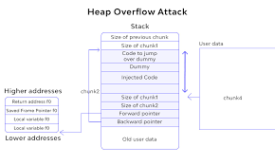
Off-by-one Error: A specific type of overflow where the overflow occurs just by one byte, potentially allowing for exploitation of the adjacent memory space without crashing the program.
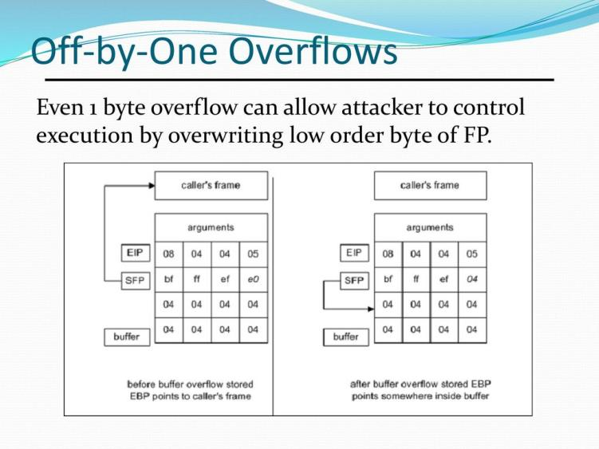

Integer Overflow: This happens when an arithmetic operation exceeds the maximum value that can be stored, leading to unexpected behavior and potential buffer overflows.
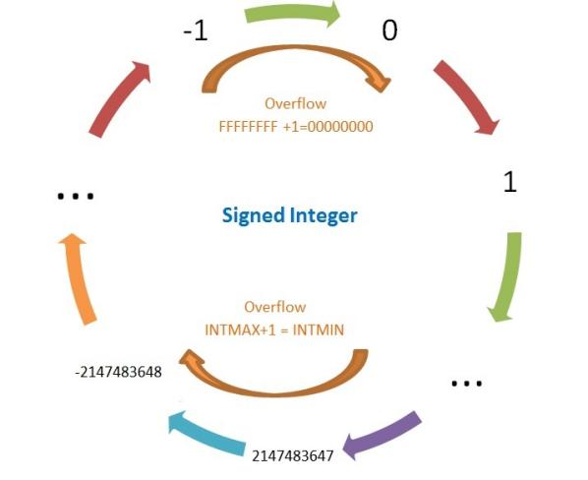

2.3 Impact of Buffer Overflow Attacks
- Security Breach: Attackers can execute arbitrary code, leading to unauthorized access to systems and data breaches.
- System Instability: Crashes and abnormal behaviors can disrupt service availability.
- Data Loss or Corruption: Critical data may be overwritten or deleted.
- Financial Loss: Organizations can incur costs related to remediation, legal actions, and loss of reputation.

2.4 Mitigation Measures
Bounds Checking: Implementing checks to ensure that data does not exceed buffer limits.
Use of Safe Functions: Utilizing safer alternatives to functions like strcpy (e.g., strncpy, snprintf).
Memory Protection Mechanisms: Employing technologies such as Address Space Layout Randomization (ASLR) and Data Execution Prevention (DEP).
Code Auditing and Analysis: Regularly reviewing and testing code for vulnerabilities.
Using High-Level Languages: Adopting languages that automatically manage memory (e.g., Python, Java).

Long Password Denial of Service (DoS) Attacks
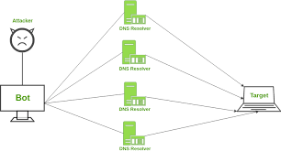

3.1 Definition
A long password DoS attack targets authentication mechanisms by sending excessively long or malformed password strings, overwhelming the system’s ability to process requests, potentially leading to service unavailability.

3.2 Methodology
Identifying Target: The attacker identifies a vulnerable system with weak password validation.
Crafting Long Passwords: Creating password strings that exceed typical length limits, often exceeding 255 characters.
Flooding Requests: Sending numerous authentication requests with long passwords to the target system, causing resource exhaustion.
Exploiting Weaknesses: The attack can leverage weaknesses in input handling, leading to application crashes or delays.

3.3 Impact of Long Password DoS Attacks
- Service Disruption: Legitimate users may be unable to access services.
- Resource Exhaustion: Systems may become slow or unresponsive due to processing large requests.
- Increased Operational Costs: Organizations may incur costs for increased monitoring and mitigation.

3.4 Mitigation Measures
Input Validation: Strictly validating input lengths and rejecting requests that exceed reasonable limits.
Rate Limiting: Implementing limits on the number of authentication attempts from a single source.
CAPTCHA Implementation: Adding CAPTCHA challenges to distinguish between human and automated requests.
Monitoring and Alerts: Setting up monitoring to detect unusual patterns of authentication requests.

4. Conclusion
Both buffer overflow and long password DoS attacks pose serious risks to information security. Understanding these threats, their impacts, and implementing effective mitigation strategies is crucial for maintaining secure and reliable systems.

5. References
- Miller, B. P., & Voas, J. M. (2018). "Buffer Overflow Attacks: A Comprehensive Review." IEEE Security & Privacy.
- West, J. (2019). "Understanding Long Password DoS Attacks." Journal of Cybersecurity Research.
- Beattie, S., & Doss, J. (2020). "Memory Corruption: Buffer Overflows and More." ACM Transactions on Software Engineering and Methodology.
- OWASP Foundation. (2023). "OWASP Top Ten Project: Security Risks." OWASP.
- Howard, M., & LeBlanc, D. (2003). "Writing Secure Code." Microsoft Press.

